LAB #3

Inductive Reactance



Fall 2022

**CSE-203L CS 2 LAB**

Submitted by: MUHAMMAD SADEEQ

Registration No.: 21PWCSE2028

Section: C

“On my honor, as a student of the University of Engineering and Technology, I have neither given nor received unauthorized assistance on this academic work”

Submitted to:

Engr. Faiz Ullah

(1 Nov 2022)

Department of Computer systems engineering

University of Engineering and Technology, Peshawar

## Objective:

Inductive reactance will be examined in this exercise. In particular, its relationship to inductance and frequency will be investigated, including a plot of inductive reactance versus frequency.

## Theory Overview:

The current – voltage characteristic of an inductor is unlike that of typical resistors. While resistors show a constant resistance value over a wide range of frequencies, the equivalent ohmic value for an inductor, known as inductive reactance, is directly proportional to frequency. The inductive reactance may be computed via the formula:

XL= 2 π f L

## The magnitude of inductive reactance may be determined experimentally by feeding an inductor a known current, measuring the resulting voltage, and dividing the two, following Ohm’s Law. This process may be repeated across a range of frequencies in order to obtain a plot of inductive reactance versus frequency. An AC current source may be approximated by placing a large resistance in series with an AC voltage, the resistance being considerably larger than the maximum reactance expected.

## Equipment :

1. 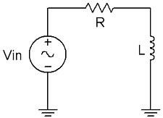AC Function Generator
2. Oscilloscope DMM

**Components:**

1. 1 mH inductor
2. 10 mH inductor
3. 10 kΩ Resistor

**Procedure: Figure 1**

1. **Current Source**

Using Figure 1 with Vin=10 Vp-p and R=10 kΩ, and assuming that the reactance of the inductor is much smaller than 10k and can be ignored, determine the circulating current using measured component values and record in Table 1.

1. **Measuring Reactance**

Build the circuit of Figure 1 using R=10 kΩ, and L=1 mH. Place one probe across the generator and another across the inductor. Set the generator to a 1000 Hz sine wave and 10Vp-p. Make sure that the Bandwidth Limit of the oscilloscope is engaged for both channels. This will reduce the signal noise and make for more accurate readings.

1. Calculate the theoretical value of XL using the measured inductor value and record in Table2.
2. Record the peak-to-peak inductor voltage and record in Table 2.
3. Using the source current from Table 1 and the measured inductor voltage, determine the experimental reactance and record it in Table 2. Also compute and record the deviation.
4. Repeat steps three through five for the remaining frequencies of Table 2.
5. Replace the 1 mH inductor with the 10mH unit and repeat steps two through six, recording results in Table 3.
6. Using the data of Tables 2 and 3, create plots of inductive reactance versus frequency.

|  |  |
| --- | --- |
| i source (p-p) | 1mA |

**Table 1**

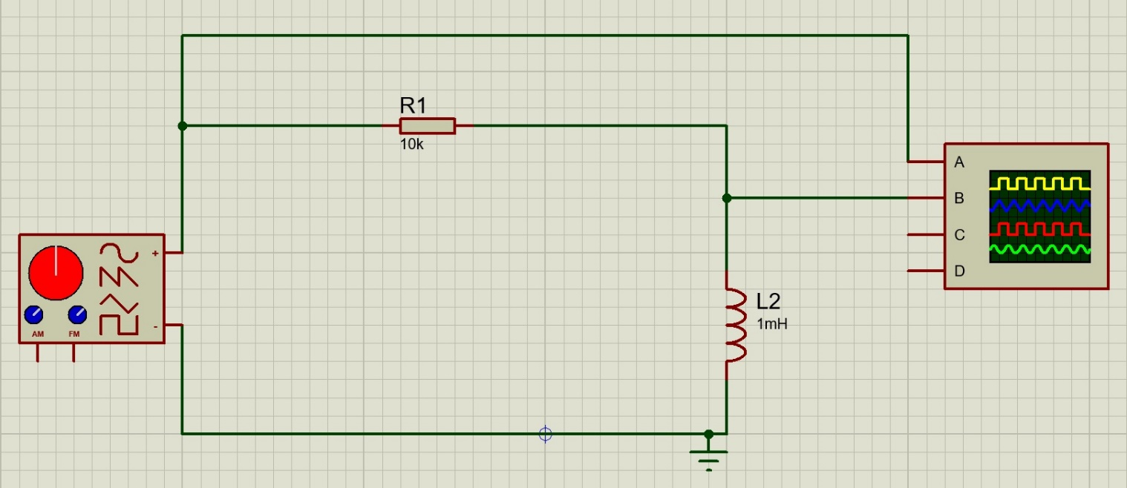

**Figure 2**

|  |  |  |  |  |
| --- | --- | --- | --- | --- |
| **Frequency** | **XL Theory** | **VL(P-P) Exp** | **XL Exp** | **%Dev** |
| 1K | 6.28 Ω | 6.1 mV | 6.1 Ω | -2.8 % |
| 2K | 12.58 Ω | 12.6 mV | 12.6 Ω | 0.15 % |
| 3K | 18.84 Ω | 19 mV | 19 Ω | -0.84 % |
| 4K | 25.12 Ω | 25.5 mV | 25.5 Ω | -1.5 % |
| 5K | 31.4 Ω | 31.5 mV | 31.5 Ω | -0.31 % |
| 6K | 37.68 Ω | 38.5mV | 38.5 Ω | -2.1 % |
| 8K | 50..24 Ω | 50.5mV | 50.5 Ω | -0.5 % |
| 10K | 62.8 Ω | 63mV | 63 Ω | -0.31 % |

**Table 2**

|  |  |  |  |  |
| --- | --- | --- | --- | --- |
| **Frequency** | **XL Theory** | **VL(P-P) Exp** | **XL Exp** | **%Dev** |
| 10K | 628.31 Ω | 0.64 V | 640 Ω | 1.86 % |
| 20K | 1256.63 Ω | 1.26 V | 1260 Ω | 0.26 % |
| 30K | 1884.95 Ω | 1.88 V | 1180 Ω | -0.26 % |
| 40K | 2513.27 Ω | 2.45 V | 2450 Ω | -2.517 % |
| 50K | 3141.59 Ω | 3.05 V | 3050 Ω | -2.91 % |
| 60K | 3769.91 Ω | 3.6 V | 3600 Ω | -4.50 % |
| 80K | 5026.54 Ω | 4.5 V | 4500 Ω | -10.47 % |
| 100K | 6283.18 Ω | 5.35 V | 5350 Ω | -14.85 % |

**Table 3**

**Conclusion:**

In this lab, we understand how to measure the inductive reactance of inductor connected in series with a resistor and voltage source in Proteus 8 software and also calculate the difference between experimental and theoretical values.

## Questions:

1. What is the relationship between inductive reactance and frequency?

**Answer**: Inductive reactance has a direct relationship with frequency.

1. What is the relationship between inductive reactance and inductance?

**Answer**: Inductive reactance has a direct relationship with the inductance of the inductor.

1. If the 10mH trial had been repeated with frequencies 10 times higher than those in Table 3, what effect would that have on the experiment?
2. Do the coil resistances have any effect on the plots?